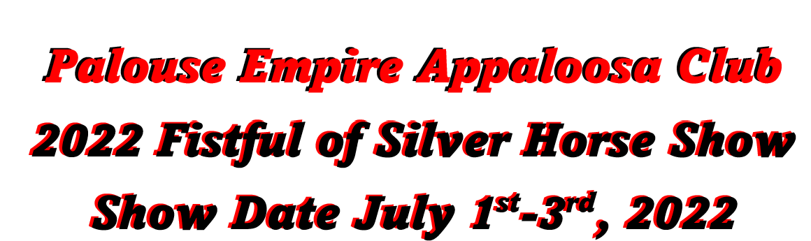
High Point Buckle: ($150.00)
- ApHC Youth ___Sponsored___
- ApHC Non-Pro Walk-Trot __ Sponsored____
- ApHC Non-Pro 19 & Over ___Sponsored____
- ApHC Gaming Non-Pro 19 & Over __Sponsored_____
- ApHC Gaming W/T __Sponsored______
- ApHC Performance Horse ___Sponsored___
- Open English Horse ___Sponsored_____
- Open Western Horse ___Sponsored______
- Open Walk-Trot 10 & Under ________________
- Open Youth 17 & Under ________________
- Open Senior 18 & Over ________________
- Miniature horse __Sponsored__
- Driving Horse / Pony __Sponsored___
- 4-H __Sponsored____
- ApHC Ranch Working/Reining __Sponsored _____

 |  | Highpoint total: |  | _________________
Class Sponsor:
Class Number(s)_________________________________________________
How many classes_____________ x $35 = total________________________

Bronze, Silver, or Gold Sponsors (Day Sponsors)
Which Level: Bronze / Silver / Gold (please circle one)

Ribbon Sponsor $25
Includes: Facebook page announcement
Award: Double Flat and Rosette Ribbon

Class Sponsorship $35
Includes: Facebook Page Link post and website link, quarter page in program, and award at the award table.

Buckle Sponsorship $150
Includes: FB page post and Website link, listing in show program,
Awards: 1 buckle

Bronze Sponsor $300
Includes: FB page post and Website link, listing in ½ pg show program, banner hanging at events and vendor spot at show
Awards: 2 buckles, and Rosettes Ribbon

Silver Sponsor $400
Includes: FB page post and Website link, listing in full page show program, banner hanging at events and vendor spot at show
Awards: 2 buckles and Rosettes Ribbon, 1 monogram award

Gold Sponsor $500
Includes: Banner Hung at Events, Links on Our Website & Facebook, 2 Page Ad in Our Show Program, Vendor Space at Events, and Sponsor
Awards: 3 buckles and Rosette’s ribbon and 2 monogram awards

Sponsor Name: | _______________________________________  Individual / Business (circle one)
Address: | _______________________________________  _______________________________________
City/State/Zip: | _______________________________________
Email address: | _______________________________________
Phone:  Website: | _______________________________________  _______________________________________
Please provide us with business cards, business logo and banner (if level sponsor). We will handle all the rest from here!
To our Sponsors:
Our 2022 Fistful of Silver ApHC and All Breed Open Show is the only 4pt ApHC show in the west coast for 2022! We are already expecting a bigger turn out! We are also offering 3pt show to Washington State Horseman participant. We have already started our advertising of the show with social medica, emails, website, word of mouth, ApHC Association show listing and much more! We already pulling out all the perks for this show to be the best of the West Coast. Our Appaloosa family is strong and are extremely close, we treat our sponsors like family as well. Thank you for sponsoring at our 2022 show and Welcome to the Appaloosa Family!

Class and High Point Sponsorships are on a first-come, first served basis. If your High Point or Class has already been sponsored, you will be notified and given the opportunity to sponsor an alternate class or award. All Sponsorship Levels are for the 2022 year only, all will be announced on our Facebook page and at the show throughout the day and listed in the 2022 Fistful of Silver Show Premium Book. Each Level will also state more opportunities for our sponsors

Sponsorships will be updated on the website within 1 week of receipt. Sponsorships are due no later than June 15th, 2022.

Sponsorship Tax-write off is in the works. Please bare with us as we wait for our Sponsorship number.

Send completed sponsorship form to:
Palouse Empire Appaloosa Club
c/o Sponsorships- Nicole Graham
6915 N Garfield Rd
Spokane, WA 99224
Phone: 541-701-4274
Email: peacoffice1@gmail.com
Website: www.peaclub.com

